# Kafka CLI (command line interface)

# Include Kafka binaries in the path. HDP includes the kafka and installs at /usr/hdp/current/kafka-broker

export PATH=$PATH:/usr/hdp/current/kafka-broker/bin

**Step 1**

Create Kafka Topic

kafka-topics.sh --create --zookeeper cxln1.c.thelab-240901.internal --replication-factor 1 --partitions 1 --topic debabrata_test_topic

To View list of topics:

kafka-topics.sh --list --zookeeper cxln1.c.thelab-240901.internal



**Step 2**

Create Kafka Producer and write some sample messages.

kafka-console-producer.sh --broker-list cxln3.c.thelab-240901.internal:6667 --topic debabrata_test_topic

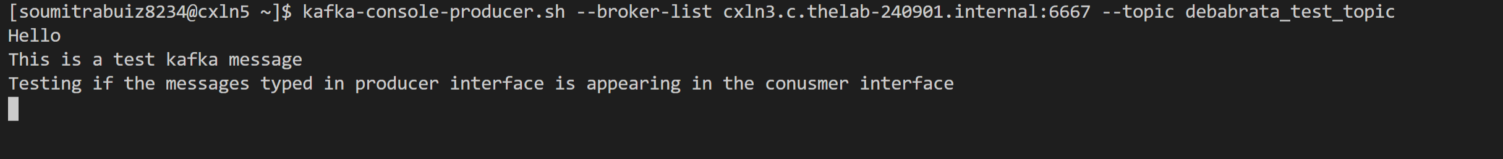

**Step 3**

Create Kafka consumer subscribed to the topic and verify if the messages written at the producer terminal is appearing in the consumer terminal.

kafka-console-consumer.sh --bootstrap-server cxln1.c.thelab-240901.internal:6667 --topic debabrata_test_topic --from-beginning

